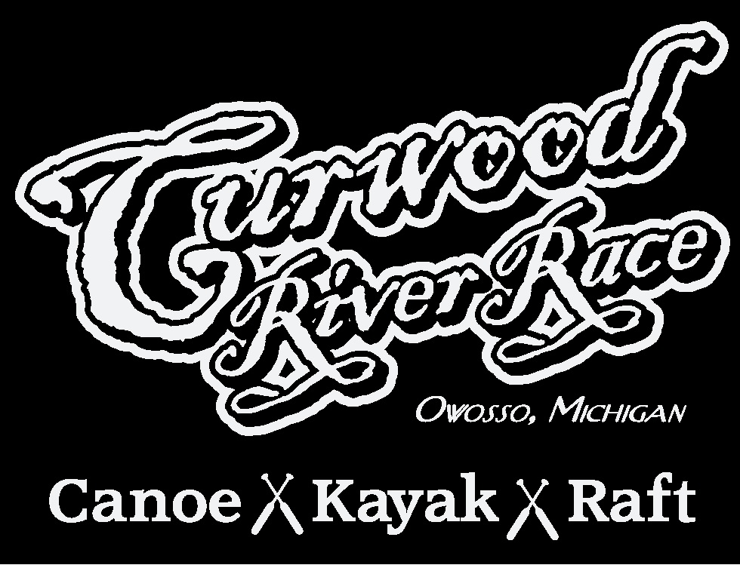

Registration & Guidelines

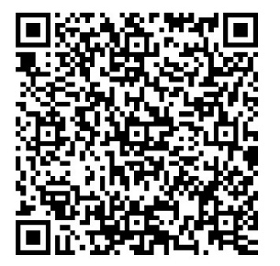

Pre-Registration Deadline: May 15, 2024

General Guidelines

The 2024 Curwood River Race is scheduled for Saturday, June 8.

Race begins at McCurdy Park in Corunna

Rafts will launch first at 5:30
Canoes will launch second
Kayaks will launch third

All paid participants pre-registered by May 15, 2024 will be guaranteed a one of a kind Curwood River Race shirt. Adults 21 and older will receive entrance into the beer tent at the Sideline Beer Tent following the race. Pre-registration cost is $20 per racer. Registration after May 15, 2024 is $25 per racer.

On site registration the day of the event from 4:00-5:15 PM shirts are not guaranteed for late registration.

Completed registration form, payment and signed waiver can be mailed to:
Curwood River Race
152 E Howard St
Suite A
Owosso, MI 48867

You can also submit payment using this QR code:
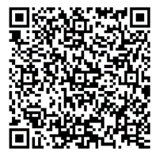
If paying this way, please make sure to put a name of the Racer Racing

If racing together on a raft or canoe, please return registration forms together

Only participants with paid registration will be eligible for prizes

Finish line will be at the walk bridge by Curwood Castle

Departure and boat pick up from the river will be at the Vista Building(Formerly Baker College/ Bentley campus off of M52)
Questions: Karen.HarrisElectric@gmail.com or (989)277-3746

Rules

It is mandatory that all participants in the races wear a life preserver and shoes

Alcoholic beverages are not permitted during the races

No motors of any kind are permitted to either move the craft or spray observers with forced water

All participants must sign a waiver of liability form

All crafts must be numbered and the participant's picture taken before the craft enters the water

There will be a $30 handling fee assessed for non-sufficient fund checks returned by the bank
Kayaks must be single person operated

2024 Curwood River Race
Waiver of Liability

Racers Name: ________________________________________________

By submitting your application you are agreeing to abide by all rules set forth for this even. Failure to comply may result in immediate removal from this event without refund.

ADULT WAIVER OF LIABILITY

I acknowledge that I have voluntarily applied to participate in the 2024 Curwood Rive Race, being held during the Curwood Festival.

I AM AWARE THAT ANY EVENT INVOLVING ENTERING THE RIVER IS A POTENTIALLY HAZARDOUS ACTIVITY, AND I AM VOLUNTARILY PARTICIPATING IN THIS ACTIVITY WITH FULL KNOWLEDGE OF THE POTENTIAL DANGER INVOLVED. I AGREE TO ASSUME ANY AND ALL RISKS OF BODILY INJURY TO MYSELF.
I VERIFY THIS STATEMENT BY SIGNING BELOW.

As consideration for being permitted to participate in this event, I hereby agree that I, my assignees, heirs, distributees, guardians, next of kin, spouse, partner and/or legal representatives will not make a claim against, sue, or attach the property of the Curwood Festival organizers or for injury or damage resulting from the negligence or other acts, however caused, by any director, employee, agent, or volunteer of the Curwood Festival, or any businesses associated with the Festival. Moreover, I forever release the Curwood Festival organizers, and their officers, directors, employees, agents, volunteers, and/or representatives along with sponsors of the event from and against any and all claims, demands, causes of action, losses, liabilities, damages and expenses (including reasonable attorneys' fees and costs) that I, my assignees, heirs, distributees, guardians, next of kin, spouse, and legal representatives now have, or may hereafter have, for injury or damage resulting from my participation in the Curwood River Race event.

I HAVE CAREFULLY READ THIS AGREEMENT AND FULLY UNDERSTAND ITS CONTENTS. I AM AWARE THAT THIS IS A RELEASE OF LIABILITY AND A CONTRACT BETWEEN THE CURWOOD FESTIVAL AND ME AND I SIGN IT OF MY OWN FREE WILL.

MINOR WAIVER LIABILITY

PARENT OR GUARDIAN of minors: I, (please print) ____________________________, As a parent or guardian of the above-named minor, personally assume any and all risks of my child(ren)'s or ward's (wards') participation in the event. Furthermore, I give permission for my child(ren) or ward(s) to participate in the event, and further agree, individually and on behalf of my child(ren) or ward(s) to all the terms and conditions stated above. I ALSO AGREE TO DEFEND AND INDEMNIFY CURWOOD FESIVAL, EKS Investments, Inc. and Retriever Solutions AGAINST ANY AND ALL CLAIMS MADE ON BEHALF OF ANY CHILD(REN) OR WARD(S) OF MINE.

Name (Print) _____________________________________________________

Signature ________________________________________________________

Date ____________________________________________________________

